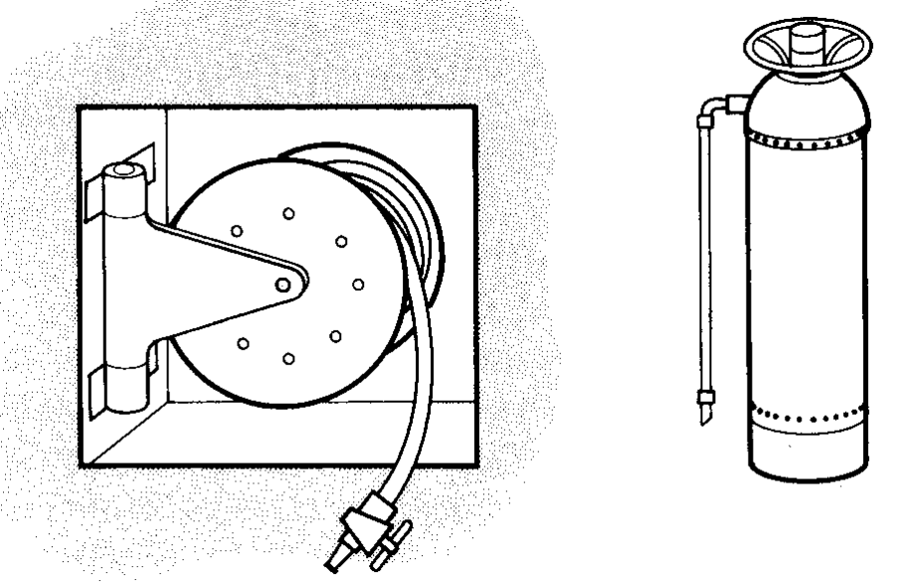
Fire extinguishers

Figure 2. Hose point (a) and pressurized water extinguisher (b)

The normally available fire extinguishers and the types of fire they can be used for are as follows.

Water
Used in large quantities water reduces the temperature and puts out the fire. The steam generated also helps to smother the flames as it displaces the air and therefore the oxygen essential to the burning process. However, for various technical reasons, water should be used only on burning solids such as wood, paper and some plastics. A typical hose point and a typical pressurized water extinguisher is shown in Fig. 2.

Foam extinguishers
These are used for fighting oil and chemical fires. The foam smothers the flames and prevents the oxygen in the air from reaching the burning materials at the seat of the fire. Water alone cannot be used because oil floats on the water and this spreads the area of the fire. A typical foam extinguisher is shown in Fig. 3(a).
Note: Since both water and foam are electrically conductive, do not use them on fires associated with electrical equipment or the person wielding the hose or the extinguisher will be electrocuted.

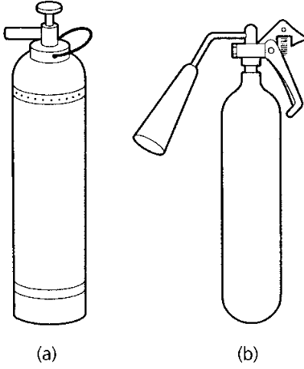
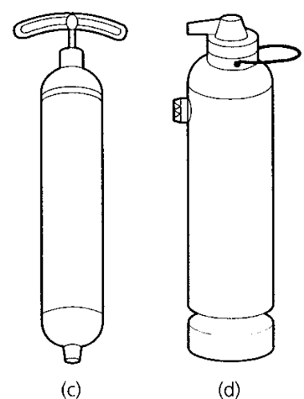

Fig. 3. Fire extinguishers:(a) foam; (b) CO2 ; (c) vaporizing liquid; (d) dry powder

Carbon dioxide (CO2) extinguishers
These are used on burning gases and vapours. They can also be used for oil and chemical fires in confined places. The carbon dioxide gas replaces the air and smothers the fire. It can be used only in confined places, where it cannot be displaced by draughts.

Note: If the fire cannot breathe neither can you, so care must be taken to evacuate all living creatures from the vicinity before operating the extinguisher. Back away from the bubble of CO2 gas as you operate the extinguisher, do not advance towards it. Figure 3.(b) shows a typical CO2 extinguisher.

Vaporizing liquid extinguishers
These include CTC, CBM and BCF extinguishers. The heat from the fire causes rapid vaporization of the liquid sprayed from the extinguisher and this vapour displaces the air and smothers the fire. Since a small amount of liquid produces a very large amount of vapour, this is a very efficient way of producing the blanketing vapour. Any vapour that will smother the fire will also smother all living creatures which must be evacuated before using such extinguishers. As with CO2 extinguishers always back away from the bubble of vapour, never advance into it. Vaporizing liquid extinguishers are suitable for oil, gas, vapour and chemical fires. Like CO2 extinguishers, vaporizing liquid extinguishers are safe to use on fires associated with electrical equipment. A typical example of a vaporizing liquid extinguisher is shown in Fig. 3 (c).

Dry powder extinguishers
These are suitable for small fires involving flammable liquids and small quantities of solids such as paper. They are also useful for fires in electrical equipment, offices and kitchens since the powder is not only non-toxic, it can be easily removed by vacuum cleaning and there is no residual mess.
The active ingredient is powdered sodium bicarbonate (baking powder) which gives off carbon dioxide when heated. A typical example of a dry powder extinguisher is shown in Fig. 3(d).

General rules governing the use of portable extinguishers

• Since fire spreads quickly, a speedy attack is essential if the fire is to be contained.
• Sound the alarm immediately the fire is discovered.
• Send for assistance before attempting to fight the fire.
• Remember:
(a) Extinguishers are provided to fight only small fires.
(b) Take up a position between the fire and the exit, so that your escape cannot be cut off.
(c) Do not continue to fight the fire if
(i) it is dangerous to do so
(ii) there is any possibility of your escape route being cut off by fire, smoke, or collapse of the building
(iii) the fire spreads despite your efforts
(iv) toxic fumes are being generated by the burning of plastic furnishings and finishes
(v) there are gas cylinders or explosive substances in the vicinity of the fire.
If you have to withdraw, close windows and doors behind you wherever possible, but not if such actions endanger your escape. Finally, ensure that all extinguishers are recharged immediately after use.

Task 1. Fill in the table using the information from the text.
No. | Type of extinguisher | Kind of fire | How it works | Where it can be used
1 | Water | burning solids such as wood, paper and some plastics | reduces the temperature and puts out the fire
2
3
4
5

Task 2. Complete the text with suitable verbs. There are three extra verbs.

put out, fight, recharge, cut off, send, call, produce, close, sound, set off

When you discover the fire ___ (1) the alarm immediately. Before attempting to fight the fire you need to ____ (2) for assistance. You can ____ (3) small fires with extinguishers. Fire, smoke, or collapse of the building can ____ (4) your escape route. Burning of plastic elements can ___(5) toxic fumes. When you leave the building, ___(6) windows and doors behind you. After the extinguishers were used you need to _____ (7) them.

Fire precautions and prevention

Fire precautions
It is the responsibility of employers and their senior management (duty of care) to ensure the safety of their employees in the event of fire. The following precautions should be taken.
- Ensure ease of exit from the premises at all times – emergency exits must not be locked or obstructed.
- Easy access for fire appliances from the local brigade.
- Regular inspection of the plant, premises and processes by the local authority fire brigade’s fire prevention officer.
- No new plant or processes involving flammable substances should be used without prior notification and inspection by the fire prevention officer.
- The above point also applies to the company’s insurance inspector.
- Regular and frequent fire drills must be carried out and a log kept of such drills including the time taken to evacuate the premises.
- A roll call of all persons present should be taken immediately the evacuation is complete.
- A meeting of the safety committee should be called as soon as possible after a fire drill to discuss any problems, improve procedures and to learn lessons from the exercise.

Task 3. Put the expressions from the text into categories and translate them.

emergency exits
fire appliances
regular inspection
flammable substances
prior notification
insurance inspector
fire drills
fire prevention officer
roll call
safety committee
easy access
local brigade

1.Inspection |  | 2. Actions and equipment
Expression | Translation | Expression | Translation

Fire prevention

Prevention is always better than cure, and fire prevention is always better than fire fighting. Tidiness is of paramount importance in reducing the possibility of outbreaks of fire. Fires have small beginnings and it is usually amongst accumulated rubbish that many fires originate. So you should make a practice of constantly removing rubbish, shavings, offcuts, cans, bottles, waste paper, oily rags, and other unwanted materials to a safe place at regular intervals. Discarded foam plastic packing is not only highly flammable, but gives off highly dangerous toxic fumes when burnt.
Highly flammable materials should be stored in specially designed and equipped compounds away from the main working areas. Only minimum quantities of such materials should be allowed into the workshop at a time, and then only into non-smoking zones. The advice of the local authority fire brigade’s fire prevention officer should also be sought. It is good practice to provide metal containers with air-tight hinged lids with proper markings as to the type of rubbish they should contain since some types of rubbish will ignite spontaneously when mixed. The lids of the bins should be kept closed so that, if a fire starts, it will quickly use up the air in the bin and go out of its own accord without doing any damage.

Task 4. List the actions necessary to prevent fires at workplace. Use imperatives.
Model: Tidiness is of paramount importance in reducing the possibility of outbreaks of fire. - Reduce the possibility of outbreaks of fire.

